Updated:
29th March 2022

Accessibility and Pre-Show information

This document contains relevant accessibility information and show information to help prepare you for your visit to our venue. This includes information such as lighting states, content or trigger warnings, running times access and the venue.

Please note that this document will include key show information and plot points.

This is a live document, which will continue to be updated during pre-production and during the season as required.

If you have any questions or concerns please contact our Accessibility Manager, Jacqueline Tooley at jacqueline@darlinghursttheatre.com

Updated:
29th March 2022

Stay Woke
by Aran Thangaratnam

About the show
Stay Woke is a four (4) person show which takes place on stage on a slightly raised platform. The setting is the inside of a ski lodge cabin.

Themes include - racism, drug use, gender, queer identity.

Running time
90 minutes (no interval)

Detailed Content warnings
- DRUG USE
Characters smoke marijuana briefly on stage. They also consume prescription drugs for recreational purposes and to excess. They discuss and reflect on this as part of the action of the play.
- COARSE LANGUAGE
The characters occasionally use coarse language.
- MISGENDERING
One of the characters repeatedly misgenders a non-binary character. The intent is not malicious, and it is discussed and called out by other characters in the play.

- RACISM
There is some discussion around racision and a brief reference to genocide.

Allergens
There is the use of theatrical vaping

Lighting and Sound
- The performers will be amplified by microphone at a natural level.
- The lighting will remain at a bright neutral state throughout the performance.
- The house lights will be dimmed throughout the performance.
- The lights will change colour at various points throughout the performance

About the show
- Niv and Sai are two brothers who head to the mountains on a ski trip with their partners.
- Niv and Sai are Sri Lankan.
- Niv has gone vegan, found love, and started his own business. He is finally succeeding in life.
- Sai brings his new girlfriend Kate on the trip.
- The story follows the attempt of the brothers to reconcile their past rivalries.
- Kate is white and makes some offhand comments which cause tensions.
- The themes of Tamil identity, queerness and interracial relationships are running themes.

The Space
The performance will take place in the Eternity Playhouse auditorium. This is accessible via 2 flights of stairs in the foyer or by taking the lift to level 1.

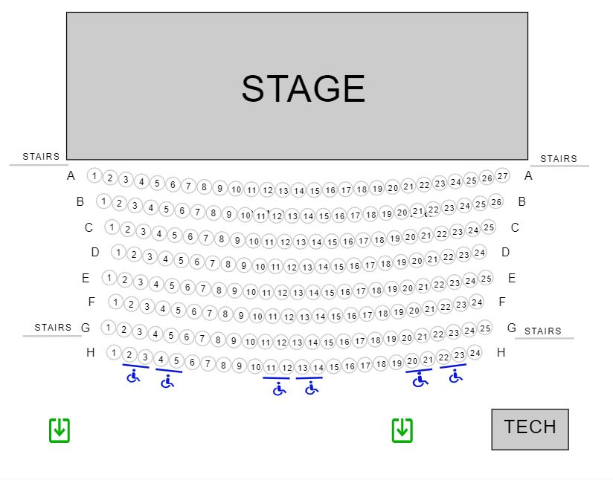

Seating
- The auditorium seats 200 people.
- Patrons will be seated in the auditorium in assigned seating. This means you can choose your seat when you purchase your tickets.
- Seating is raked from front to back, meaning that patrons in the front row will be on Stage Level, and patrons seated further back will be higher up from the stage.
- The house lights will be on when you enter the theatre.
- There will be an usher present to help you to your seat if you need.
- We have 6 wheelchair spaces which are in the back row (row H).
- Once everyone is seated, the house lights will be dimmed.
- If you need to leave at any point during the show, please exit through the same door you entered the theatre by. The usher can assist you if needed.
- Latecomers will be admitted at a suitable time at the discretion of the Front of House staff.

Visual Story - please see our Visual Story here for useful information about getting to and around Darlinghurst Theatre Company, including public transport and parking.

Access
Amenities
- There are three (3) all-gender bathrooms on the Lower Ground floor
  - A bathroom with cubicles and 1 ambulatory cubicle to the left of the Darlo Angel wall.
  - A bathroom with urinals and 1 ambulatory cubicle to the right of the Darlo Angel wall.
  - An accessible bathroom opposite the lift.
- There is a bar in the foyer on the Lower Ground floor. Access is via the central stairs or the lift.

For venue accessibility, including parking and facilities, please visit www.darlinghursttheatre.com/accessibility

